MGSC 1206 Winter 2020
Guidance on Writing Your Project Report
The notes that follow are a continuation of two previous memos,
- MGSC 1206 Group Project Winter 2020
- Guidance on Managing Projects
Both are posted in the Project folder. Read them.
In this memo, several topics are addressed:
- Grading
- Problem Statement
- Data Selection and Quality (page 3)
- Analysis (page 4)
- Conclusions and Recommendations (page 6)
- Communication – choosing and displaying the right chart (page 7)
  - Line charts (page 7)
  - Pie Charts (page 8)
  - Column Charts (page 11)
  - Bar Charts (page 14)
  - Histograms and Box and Whisker Charts (page 16)
- Storytelling (page 18)
- Observations from reports submitted in fall 2019 (page 23)

- Grading
The project was originally worth 25 points of which 3 points was for the proposal. The whole project is now worth 35 points but we will keep the proposal value at 3 points. The remaining 32 points being allocated as follows:
 | Original points | Revised points
Problem Statement | 2 | 3
Data selection and quality | 3 | 5
Analysis | 9 | 13
Conclusions | 3 | 5
Cohesion, persuasiveness and clarity | 5 | 6

In awarding points, we will follow the guidelines below:
 | Excellent | Satisfactory | Poor
Problem Statement | 3 points  Clear, specific objectives  Explanation of why study  List of specific research questions that fit objective | 2 points  Specific objective  Not clear why study  Question list incomplete or disconnect with objective | - Point  Objective not clear  No rationale  Poor list or no list
Data Selection and Quality | 5 points  Data source identified  Data is related to questions  Limitations noted on what can be generalized – clear who is being studied  Data problems with missing values and outliers identified  Data cleaning steps explained | 3-4 points  Data source identified  Data relevant to questions  Some discussion on limitations  Some data quality problems identified | - points  data source unclear  data does not appear linked to questions  no limitations  some quality problems noted
Analysis | 11-13 points  8-10 tables/charts  Charts are correctly interpreted  Choice of analyses appropriate for questions  Logical sequence to analysis | 7-10 points  6-8 tables/charts  Duplication of table with a chart  Most are interpreted correctly  Most analyses are relevant to questions | 0-6 points  4-6 charts/tables  Duplication of tables with charts  Interpretations not clear  Charts not all relevant to questions
Conclusions | 5 points  Conclusions follow obviously from analyses  Logical flow  Next steps identified and consistent with analyses | 3-4 points  Most conclusions are logical  Next steps have gaps  Some conclusions are “opinions” not supported by analyses | 0-2 points  Disconnect between analyses and conclusions  No next steps
Communication | 5-6 points  Clear logical flow  Charts/tables have appropriate titles and axes are labelled  Chart scales appropriate  Section headings compelling and informative  Good story | 3-4 points  Flow is clear  Most charts have appropriate titles and axes are labelled  Titles and headings correct but not engaging/informative | 0-2 points  Charts are screen shots  Titles, labels are defaults  Uneven flow – reads like 4 people wrote sections and pasted together

In the original memo introducing the project, a brief explanation was given on each of these elements. Some of this is repeated below.
- Problem Statement
Although, in your project proposal you attempted to explain your problem and what data you would use, you will likely change or refine the problem statement as you do the analysis.
In the problem statement, you will identify the “big” issue. A student just emailed me about their group looking at “Does working affect student GPA”. What does this really mean and why should we care?
The group should be clarifying that they are talking about students taking paid employment while they are enrolled in school full time. Do they want to limit their examination to “GPA” or more broadly look at student “performance” or student “success”. There are more measures of performance or success than just GPA so broadening the outcome may give a richer examination of paid employment.
Why should we care about this issue? Why do students work? Who works? Is working seen as a good or bad thing? (e.g., working as a research assistant to gain skills versus working at Tim Horton’s to pay bills). If working for money is seen as a necessary activity, does the type of work matter? If you see working as negative, are some students more adversely affected than others? How does working affect GPA? Not directly. Maybe working leaves less time for study or for recreation. Is losing recreation time a big deal?
The problem statement can ramble on for ages so make a brief compelling statement about why I should read your report.
Identify a set of specific questions that the report will address. Who works? How many hours? Is hours working related to GPA? In the analysis you may break up the questions into smaller questions, such as is the relationship the same for domestic and international students.
So in the section on the problem statement you will list a set of more detailed questions, but not necessarily everything that you will look at in the analysis. You are engaging the reader, not burying me in detail that will be addressed later.
If there is a lot of text, the reader loses attention. Our eye is drawn to pictures and lists because they are not boring text. So present your questions as a bulleted list to make them stand out. I may not read the other text but my eye is drawn to your list.
The list of questions will likely change as you get into the analysis.

- Data Selection and Quality
Where does your data come from? Are there limitations to this source? How will this limit your ability to generalize? For example, if you are using the 2020 class survey, are there limitations to talking only about students who were registered in MGSC 1206?

Look at Assignment #3. It was set up as if it was a mini project, or at least the start of one. The “big” issue was student retention. If we were to try to reduce the number of students who drop out, we must intervene in the student’s program early. Early was defined as during the student’s first term of study. We were concerned that students who did poorly in the first term were most likely to drop out. Who are these students? What were their high school grades like? Where were they from? When did they apply? Can we use admission data to predict first term performance? What variables are most influential? … This was a very brief problem statement.
The assignment went on to discuss what data was available. We only had a few variables. Grading systems vary around the world, and high school grades were not recorded for all students. We excluded all international students and those for whom we did not have the high school average. We then excluded transfer students. We excluded students whose fall GPA was zero because we thought they may have never attended or dropped out in September (too soon for us to act). These are data quality issues. We “cleaned” the data, but did we limit what we could then do with our analysis? We can now only talk about Canadian students entering directly from high school. This is likely only half of the entering students.
Although not part of the assignment, when we drilled into the data for our analysis, we may have discovered other problems (like the students that applied more than a year in advance, or the ones that had very strange high school averages).

Think about the source and quality issues, make a few notes to yourself, and then move on to your analysis. When you get into your analysis you will start discovering any issues with the data. What did you do with outliers? What about missing values? Maybe they don’t matter. Make notes about any data transformations or cleaning you do. Did you combine groups because sample sizes were too small?
Last term many groups analyzed the survey from 2010. Although 10 years old, there was a lot of interesting stuff that would still be applicable today (e.g., gender differences or program differences). But many groups did not clean up the numerous outliers. Many looked at programs, such as medicine and fine arts, even though these were obvious errors. Many did not note that many of their subgroups had only a few values – not enough to draw conclusions from. It is a data set with serious quality issues and cleaning is necessary. After you have decided what changes you had to make, then you can go back and write this section of the report.
If you are not careful with cleaning and transforming your data appropriately, it is not just errors that you can make, but the junk/clutter will become a significant distraction for the reader, because the reader has to filter out the junk in reading your table/chart.

- Analysis
In general, we write the analysis section first and then add the beginning and ending to the story.
As noted above, you may have to make comments on data cleaning/transformation in the analysis section. This is done when the changes only apply to a particular chart and not the whole report. It is easier to understand why and how the changes were made in the context of the specific piece of analysis.
Many research questions can be explored using simple tables or charts. Some students are trying to use regression analysis. This is commendable, but it will be challenging. Excel doesn’t like missing values for regression, so you may get an error saying you have non-numeric data (a blank). As we saw with assignment 3 and 4, it is very difficult to predict GPA. This is the case with a very large number of problems that we analyze with regression. Don’t be disappointed if you have a small R-square and big standard error.

The purpose of this project is to have you apply the process of data analysis from start to finish. You are not being evaluated on what you discover. Your grade is based upon how you do your analysis and how you communicate your problem and conclusions.

Last fall, most groups set out to do reasonable analyses but issues arose with how the analysis was presented or the group did not pay appropriate attention to data quality. Below is a graph that one group had in a draft of their report.

This graph has numerous problems. What were they trying to tell me?
The data was from the survey from fall 2019. One item they were looking at was the relationship between high school average and GPA.
The title of this chart was actually the survey question for the vertical axis.
The horizontal axis was the student’s GPA.
If the goal was to show whether HS average predicts GPA, then the axes are backwards. Note that neither axis was labelled so someone unfamiliar with the data would have no idea what was being displayed.
Look at the GPA values. Most are between 0 and 4, but one observation is 15. This outlier is likely a data entry error. It could be 1.5. It should either be eliminated or changed to 1.5.
Look at the high school averages. Three values are 0. There is no obvious way to fix these outliers, so they should be eliminated.
The chart below is an edited version of the above with a title that tries to tell what the chart is saying.

You could a regression line and a correlation coefficient to emphasize what your title is saying.
Good analysis involves good data preparation and good communication.

There are many types of charts that you can create in Excel and many ways to format your chart. Good analysis includes selecting and formatting the right chart for the task. You can also use tables in place of charts for many applications. With tables, formatting is very important. Whether tables or charts, it is critical that axes be clearly labelled and the chart/table be kept as clean and simple as possible. Color should be used “gently” so that it does not detract from the message.
Charts are often more effective than tables, but it may depend upon your audience. Readers get fatigued if there is too much text, so pictures can help hold your reader’s attention.
More on chart selection and presentation later.

- Conclusions and Recommendations
The conclusions should never be a surprise to the reader. The analysis should be sequenced such that the conclusions are obvious. Someone said that a presentation should have three parts:
- Tell me what you are going to tell me
- Tell me
- Tell me what you told me
The conclusions are simply a summary of your findings.
However, you may choose to have recommendations. These go beyond conclusions and suggest next steps. Be careful where you step.
Don’t have recommendations that do not follow from the analysis and conclusions. This is not an opportunity for you to express your personal opinions, unless you can support them with your analysis.
Many groups will have chosen a topic that they are personally passionate and interested in. The group may start the project with expectations of what they will find and what they will recommend. Most will find that the data does not give as clear conclusions as they thought it would. This is not unique to this project or the survey you used. Reality is often muddy.
However, you may be able to offer effective recommendations on how a new study can be done that will give more definitive answers. You used the data you were given, not a data set that was collected to answer the specific questions you wanted to investigate.
If you were to conduct a new research study,
- what questions would you ask?
- Who would you ask?
- How would you obtain the answers so that you were not constrained by issues of non-response or other data quality problems that you may have had to deal with?
- Imagine this report as being a pilot study that was intended to inform a larger research study.
- What would you recommend so that the larger study was successful?

- Communication - Cohesion, Persuasiveness and Clarity
It is impossible to talk about how to present your analysis without discussing persuasiveness and clarity. The above example of a scatter chart was both an example of using a scatter chart for analysis and an example of persuasiveness and clarity.
John Tukey, renowned American mathematician and statistician, once said, “The greatest value of a picture is when it forces us to notice what we never expected to see.”

Common charts are
- Line charts
- Column charts
- Bar charts
- Pie charts
- Box and whisker charts
- Histograms
- Scatter charts
Although some charts may be used to display a single variable, most are for comparisons and relationships. Most comparisons are looking at summary measures, such as averages, percentages or totals.
  - Line charts are frequently used for time series data. Time series has not been covered in this course but is a very common area of investigation. It can be looking at a single variable over time of we may wish to see how multiple variables change with time.

Below is an example of a line chart showing the changing demographics of business enrolments at Nova Scotia universities.

Some may choose to use a stacked line(area) chart, but they can become confusing.

Although the chart tells you about total enrolment, whereas the previous one did not, it can be challenging to see how the components are changing over time since the baseline for each group drifts up and down. The previous chart more clearly showed how each market was growing or shrinking.
What is the primary story that you are trying to tell?

  - Pie Charts are intended to show the percentage of individuals, sales, or some other total that is represented in each group. Consider a firm that has 4 main products groups (A – D) that it sells in four European countries. Total sales data for 2019 in $10,000 is given below:
2019 Total Sales in $10,000
 | A | B | C | D
Netherlands | 20 | 33 | 10 | 30
Austria | 35 | 24 | 20 | 30
Belgium | 16 | 43 | 25 | 50
Norway | 42 | 52 | 30 | 35

The table is not very interesting. The choice of units is poor. Multiples of $1,000 would be easier to interpret. Is there a story to tell?
You might want to make a pie chart to show how sales in the Netherlands are split among the 4 product groups.
It might be easier to read if the slices were labelled and percentages were shown.

Comparing the relative sizes of slices is not simple. Does C look to be half the size of A and a third the size of D or B? Can you tell that A plus C is approximately the same as D? Comparing areas is not easy. Comparing them in a circular manner is even harder. And don’t try making it a work of art by adding 3D perspective!

Now try comparing the relative shares of A, B, C and D. This is Chart Junk. Never add 3D perspective to a chart that is two dimensional!
Recall that initially we wanted to compare sales by product and by country. To do this with pie charts requires that we have charts for each product or for each country. Below are charts by country.

Comparing these is next to impossible. Pie charts are colorful and pretty but convey very little information and what is conveyed is difficult to interpret.

Lesson: Never use pie charts!

  - Column Charts and Bar Charts are generally seen as more appropriate than pie charts for comparing averages and percentages among groups. Most of the time people prefer column charts. We will show examples of bar charts and where to use them after exploring the use of column charts.
A simple column chart might be the following:

This chart shows total sales. Clearly, Norway has greater overall sales than the Netherlands. The countries were sequenced such that they were in increasing order of total sales. You may also want to sequence the products in order of increasing sales, but you should keep the same sequence for each country.

If you want to show how sales in each market varies across products (like a pie chart would show) then you need to scale your data to show percentages. The simplest way to do this is to use a stacked column chart.

The chart on the right has percentage on the vertical scale. Although quick and easy to create, stacked charts are not easy to read, because the base keeps moving. It would be better to scale the table to show percentage of total sales and then build a regular column chart. This is easy to do if your summary is in a pivot table.

Note that it is very important to label the vertical axis appropriately. In the above case, simply saying percentage does not tell us whether it is percentage of country sales or percentage of product sales.
Note that if you are using a Pivot Table/Chart combination, the default is to sort groups alphabetically. I sorted the countries from smallest to largest total sales before I created the chart. Pay particular attention to building charts that have one variable that is ordinal, such as
- very satisfied
- satisfied
- neutral
- dissatisfied
- very dissatisfied.
Unless you move roes/columns in your table, Excel may order the groups as
- dissatisfied
- neural
- satisfied
- very dissatisfied
- very satisfied
If you don’t get the order correct then the chart will look confusing and amateurish.
Remember that if you data set is small, you may have to merge groups. Having just
- dissatisfied
- neutral
- satisfied
may not result in a significant loss of important information and may make things easier to read.

If you have nominal groups, such as Nova Scotia, Rest of Canada, Caribbean, Africa, South Asia, China, Other, then you may want to sequence them in terms of number of students (largest group first) or in terms of distance from Halifax, or some other measure that makes sense. Alphabetic listing is likely the worst choice.

  - Bar Charts versus Column Charts
Bar charts are essentially the same as column charts, but displayed horizontally. Bar charts are often preferred when the labels are long.
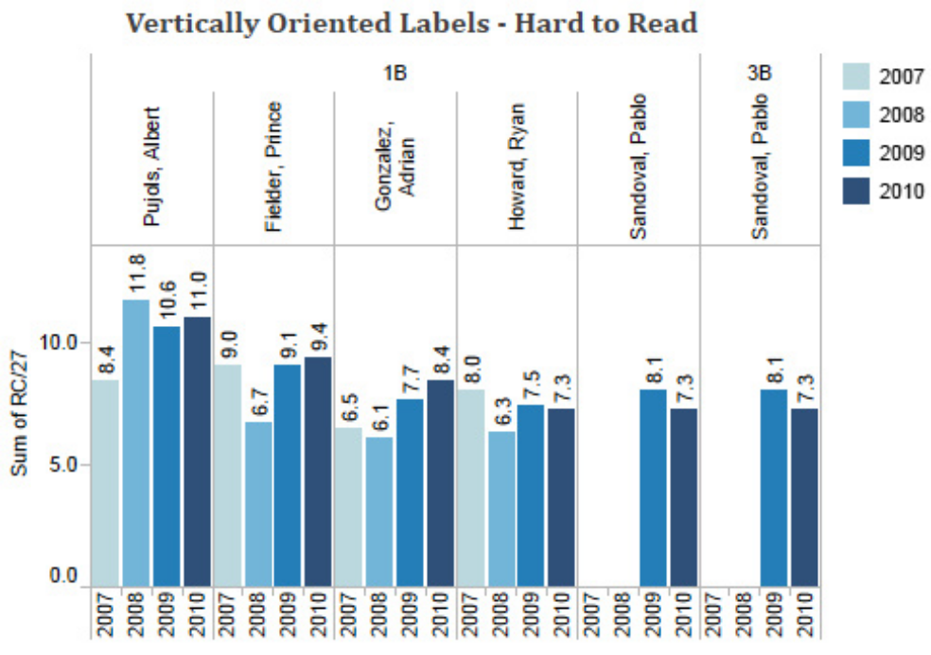
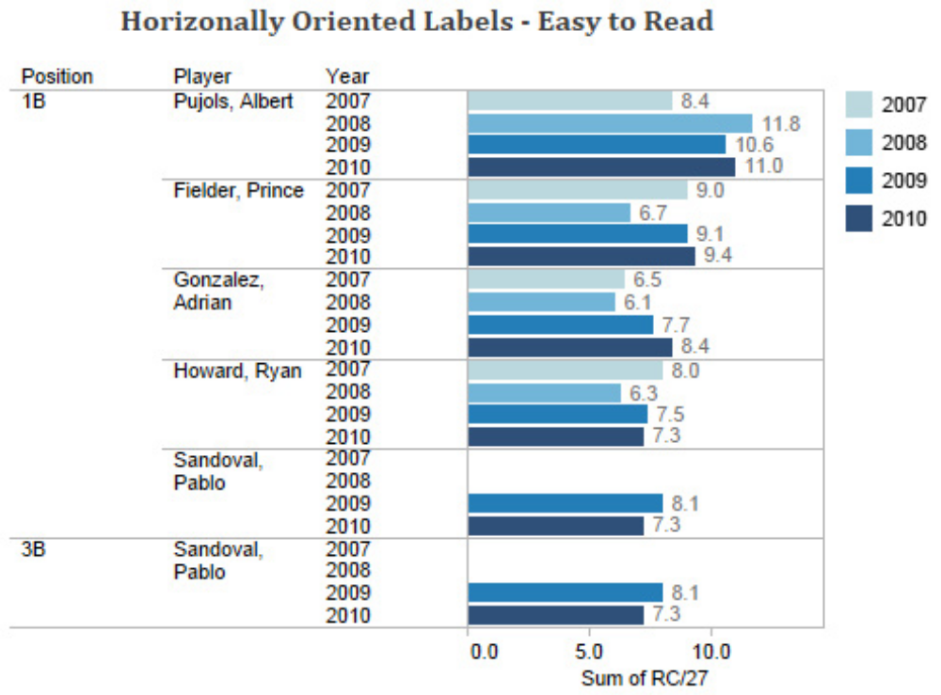
Bar charts are trickier to use when you are making multiple comparisons. In the above, the sales people were sorted from the most successful to least successful. High to low sequencing is often preferred for bar charts. Further, it is often better to integrate the factors like done above, rather than separating them.
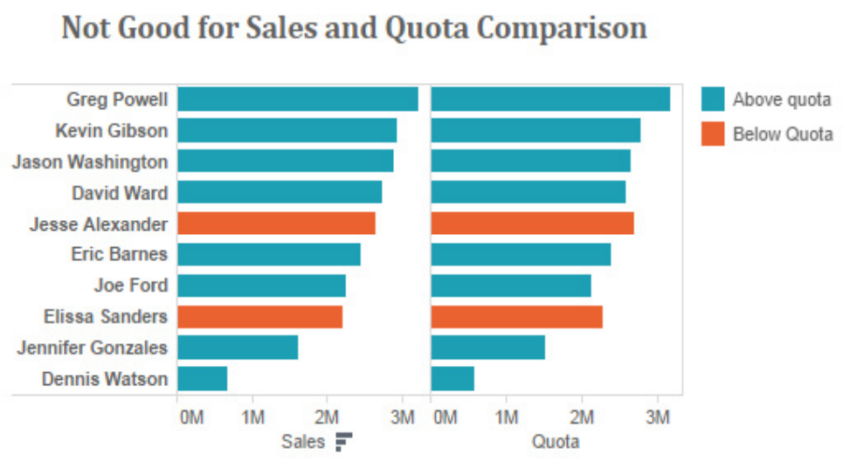
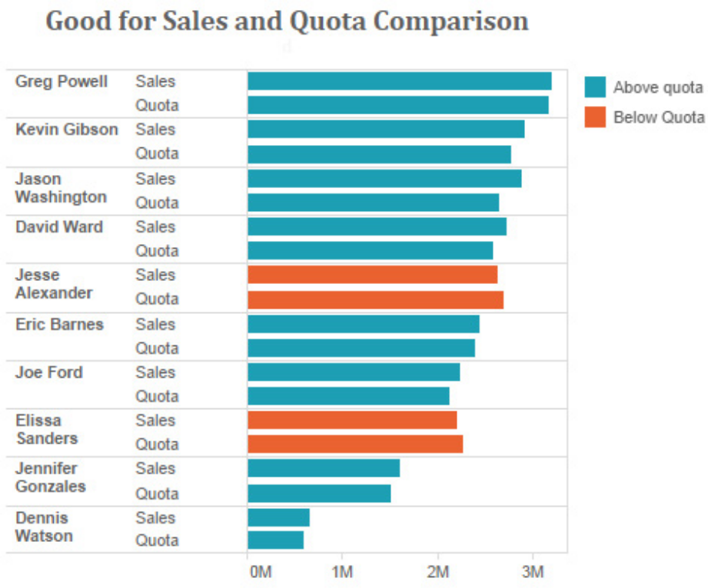

  - Histograms and Box and Whisker Charts
Both of these charts are intended to display the diversity of values, rather than simply showing the average. Histograms are best for a single data set whereas Box and Whisker charts are intended for comparing groups. When you have only one group, you want to explore the details of the group. You want to see the distribution in its fullest extent. But when you are comparing groups, this detail can be overwhelming. This is especially the case when there are many groups. Box and Whisker charts highlight only the highlights: where is the middle, what is high/low, what is very high/low, are there outliers? If there are only one or 2 groups, use a histogram. If there are 4 or more groups, use box and whisker charts. For three groups, look at each and decide.
With histograms, you must group data. Choose 5 to 15 groups, depending upon how much data you have. Use “nice” groupings so that your horizontal axis will look good. If you have more than one group, you should scale the vertical axis so that it shows the percentage in each group.

Once again, it is critically important what you choose as your vertical scale. If your intention was to show how many Card holders were low, medium or high risk as well as the income distribution, then the first histogram is best. But it is likely that you wanted to simply show how the pattern of incomes varied across risk groups, in which case, the second histogram is best.
If your objective was to highlight both the average income as well as the diversity of incomes, then a box and whisker chart is preferred.

Although Box and Whisker charts are simple and effective, they are unfamiliar to some audiences. They have been around for 50 years, but have not been mainstream until recently. If you use them, be prepared to have to explain what the chart is showing. I love them because they are so simple and can be used to compare many groups at once. But few understand what the box and the whiskers and those irregular dots represent. They will be more common place in the future, but will likely always need some explanation. They may remain a chart best used for analysis but not for communication in a final report.
The strength in histograms and box and whisker charts is that they show diversity. Averages portray everyone as being average. They reinforce stereotypes. Firms that are most successful understand, appreciate and even celebrate the diversity of their customers.

- Story Telling
Telling stories through charts has become a hot topic. Many managers talk of data visualization and dashboards. A lot of the talk is about pretty pictures and not evidence-based decision-making. Much of the commentary above has been about good and bad practices in data visualization. Story telling is somewhat different. When we were children, many of our favorite stories had great pictures. I recall how my sister could “read” a book aloud long before she learned to read. She memorized the words we said with each picture. When she saw the picture, she recited the associated words. Pictures are an essential part of good storytelling. When you are trying to make a persuasive argument to a client to buy your product, you are likely telling them a story. Good reports tell good stories.
But sometimes the charts and pictures you use are not the simple charts that we have introduced. Sometimes they are unique creations.
The picture below reflects the death toll of the war in Iraq.
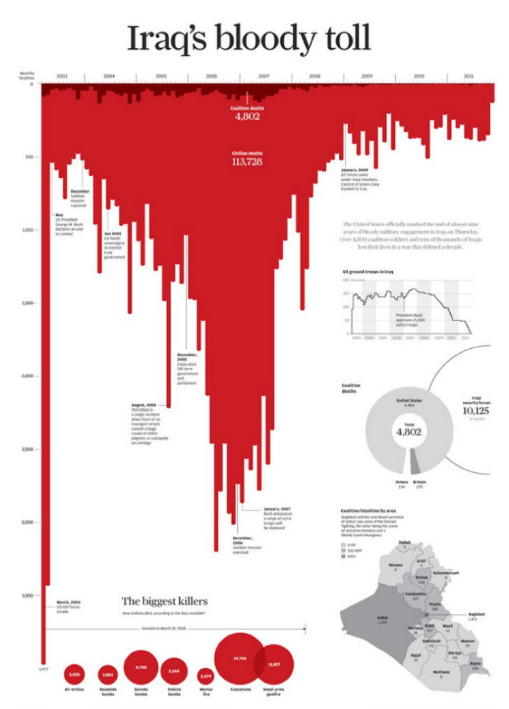
But the story can be told from a different perspective.
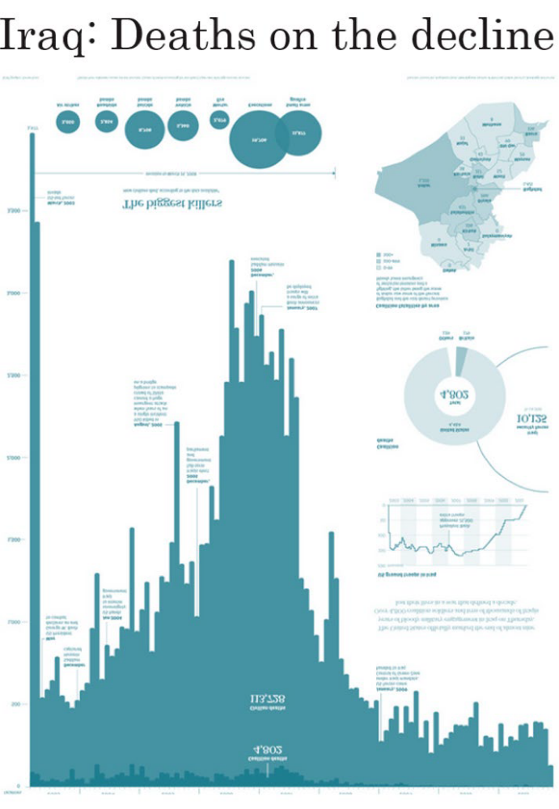
What story are you trying to tell?
15 years ago I was asked to explain student retention to faculty and administrators. The widely held belief is that students who dropped out, flunked out. Tables and statistics made little impression on anyone, so I used pictures to tell the story.
In a typical year, we recruited 2600 new students. At the end of the year, we told 300 to leave and another 1200 simply walked away.
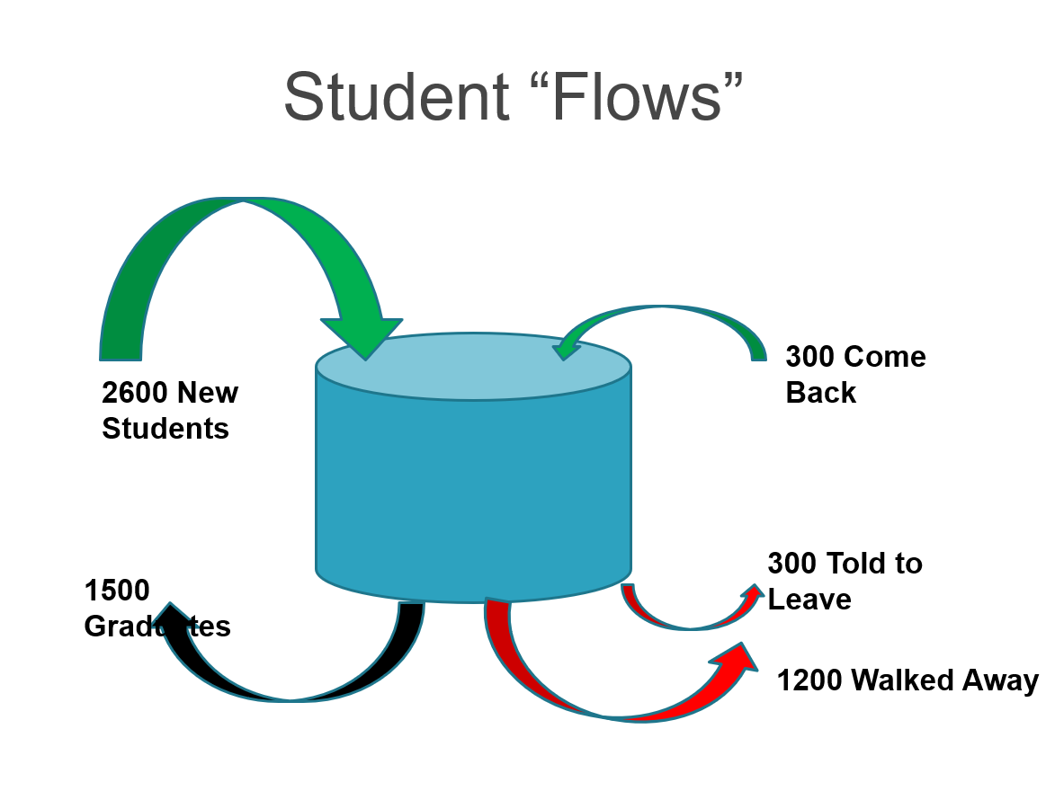
What happened to those that entered in fall 2005?
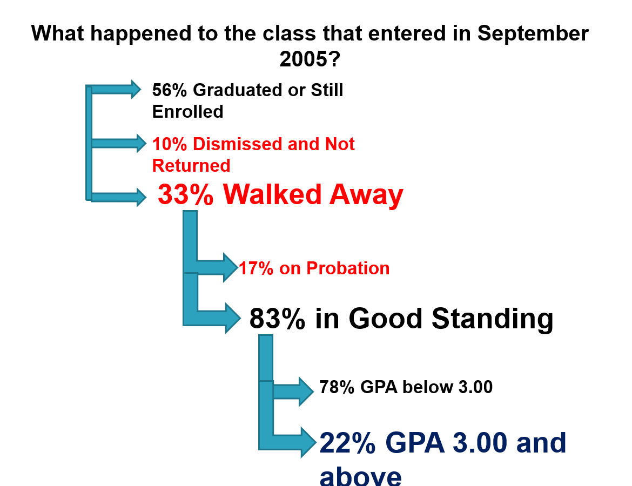

And when did they leave?
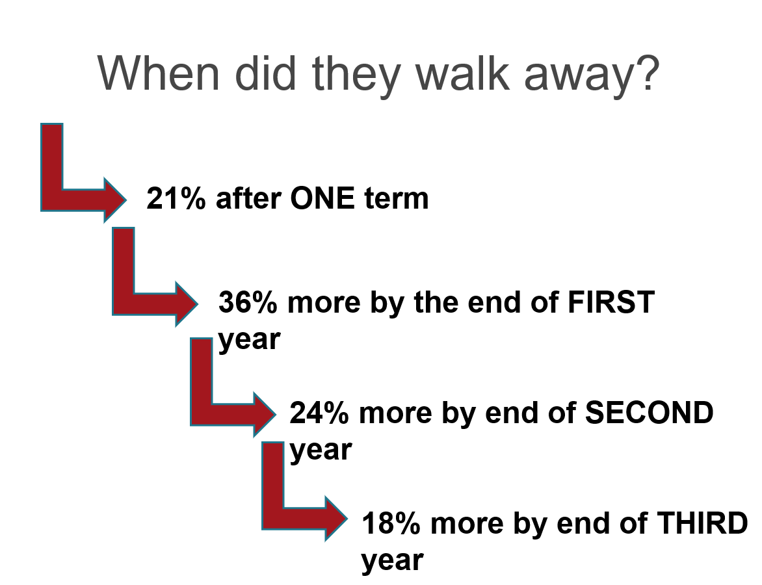
These are not our typical charts, but ones specifically designed to tell a story. Regrettably, almost no one believed me!
One of the most famous story pictures describes Napoleon’s failed attempt to defeat Russia. The chart shows the path of his army. The width of the path reflects the number of soldiers. On the picture are displayed the dates and temperatures for the advance and the retreat. It is a sad story of defeat.
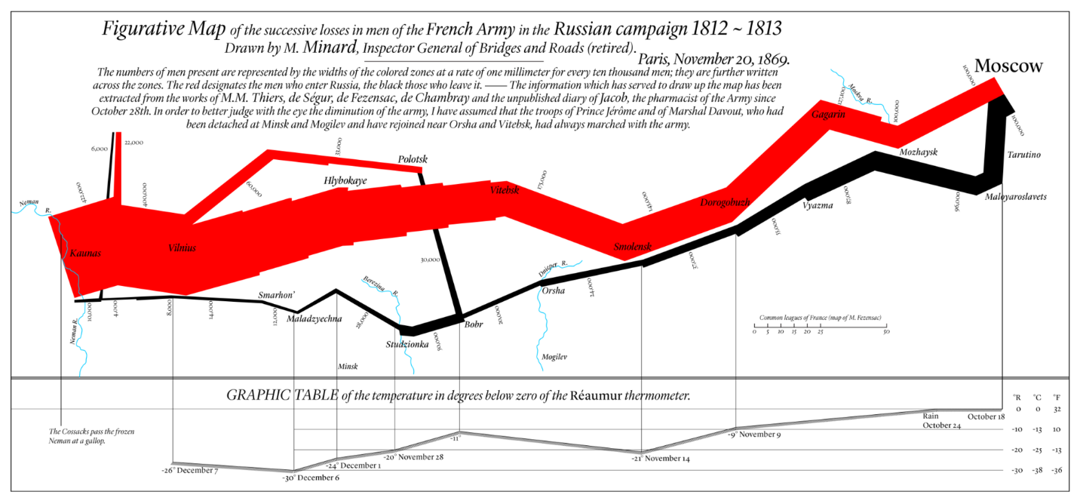
In my previous life as Registrar I was responsible for preparing bi-weekly reports on applications for the next academic year. Recruitment started in late September and continued until school started in the following September. Recruitment of Nova Scotia students is extremely competitive because the number of high school graduates has been declining by 2-3% per year for 15 years. The market has shrunk by almost 40%. Institutions have implemented many tactics to engage students sooner. Fifteen years ago, most students would apply in February, after receiving their mid-year grades. Universities would rarely make admission or scholarship offers until they saw those grades. As competition increased, admission practices changed. Offers were made sooner. Offers were made on the spot, even in the school.
How did this affect enrolment reporting and forecasting? Senior management was excited to hear that applications were up by 10% by mid-January. This was the time that serious budget planning was occurring for the next budget year. Trying to convince management to be more cautious in their budgeting was always a challenge until I gave them my “chicken graph”. My last one from 2017 is depicted below. I don’t know what the numbers ended like in September 2017. Each curve represents the cumulative number of applications over the recruitment cycle. What becomes evident is that the pattern of applications changed over time, with more students applying earlier. But because of the shifting demographics, the final number of applications is in decline. I call it the chicken graph after the expression “don’t count your chickens before they hatch”. After seeing the graph, management understood.

Management finally recognized that although applications to date were ahead of any previous year, we were likely facing a significant decline in September enrolment.
The point of these examples is that often you need to be creative to get your story across to the reader. You need to engage the reader. Capture their attention. You need to be serious and professional, but innovation in presentation may pay off. In your report for 1206, stick to tradition. There is no need to take risks, but when you graduate, it may be necessary to take risks to get noticed and heard.

- Some observations from projects done in fall 2019

- Don’t take screen shots of Excel. Copy and paste your tables and charts and then format them appropriately.
- In comparing bar charts or column charts, vertical scale must be %, otherwise hard to judge relative sizes
- 2 way charts and tables should be outcome vs factor. At most look at outcome vs 2 factors
- Combine categories to simplify tables/graphs. Often only 2-3 categories are enough.
- If more than 2 ordinal categories, make sure you sequence them -low, medium, high – Excel will sequence them alphabetically, so you will have to move one or more categories.
- If more than 2 nominal categories, often attractive if sequence largest to smallest frequency or average, unless some geographic or other sequence makes sense.
- Correlation and causation – what came first?
- Averages tell only small part of story – usually want to talk more broadly about the whole population – boxplots often better
- Histograms too busy to compare groups – use boxplots to focus attention on the most important features
- Outliers are distracting and distort averages – if necessary, trim the top and bottom 5%
- Be careful of sample sizes. When you split your data into smaller groups, they may become too small to make definitive conclusions.
- Your averages and percentages all have a margin of error of +/- 2(std error). For averages, the margin of error is 2*(std dev)/sqrt(sample size). For percentages, use 100%/sqrt(sample size). If your sample size is 100 and your standard deviation is $600, then your margin of error is +/-$120. If your sample size is 100, then your margin of error for a percentage can be as large as +/-10%.
- You don’t need to draw too much attention to the margin of error calculation, but do not discuss small differences among groups as if they are important.
- Remember that your audience is a busy senior manager who may not have time to read text in detail.
- The manager may only scan the document.
- When scanning, the eye is drawn to text that stands out – headings, bold type, underlining, text box, color.
- Tables and graphs attract the eye – graphs more so than tables. Headings/labels must be simple and clear.
- Use simple graphics without too much detail. Bar charts are better than pie charts.
- Use section headings and chart titles that tell you what comes next – they are engaging.

